Test Document for Converter APP:

Run Spring Application in eclispes

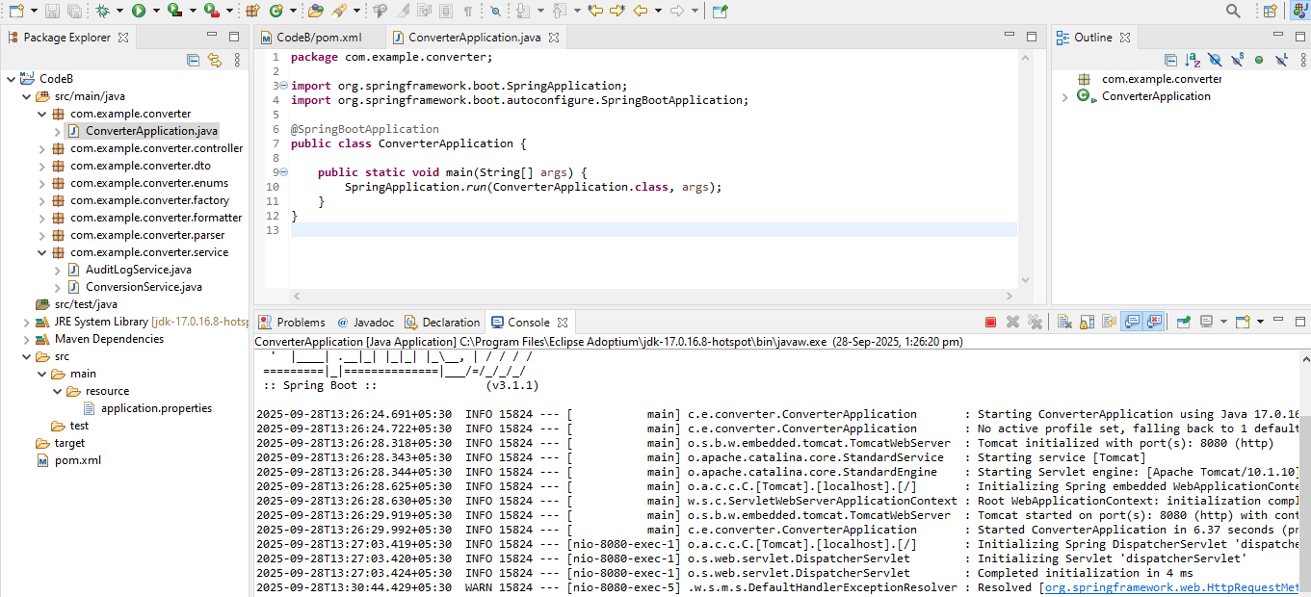

Test Conversion using Postman request

URL: http://localhost:8080/api/converts

1. Decimal to Roman Conversion

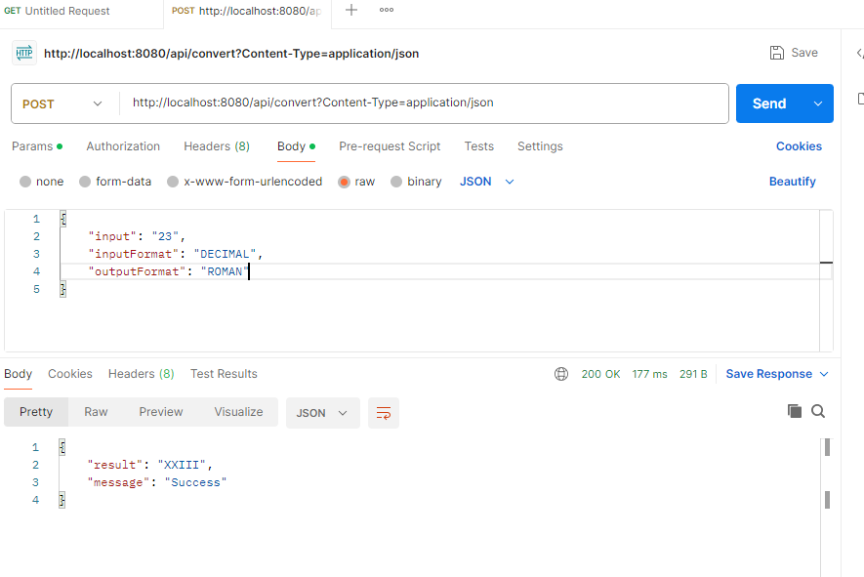

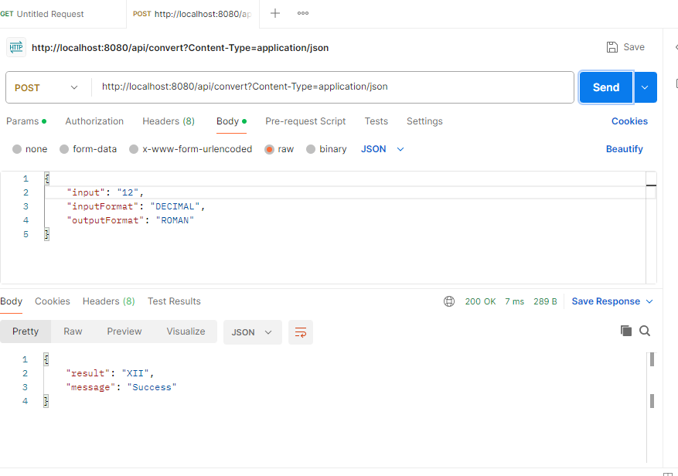

1. Binary to Roman

